***JUnit Testing Exercises***

**Exercise 1:** Setting Up JUnit

**Scenario:** You need to set up JUnit in your Java project to start writing unit tests.

**CODE:**

public class Calculator {

public int add(int a, int b) {

return a + b;

}

}

import org.junit.*;

public class CalculatorTest {

@Test

public void testAdd() {

Calculator calc = new Calculator();

int result = calc.add(5, 3);

Assert.assertEquals(8,result);

}

}

**OUTPUT:**

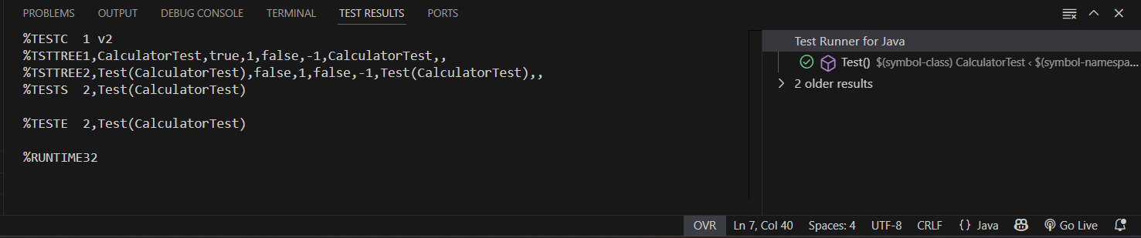

**Exercise 3:** Assertions in JUnit

**Scenario:** You need to use different assertions in JUnit to validate your test results.

**CODE:**

import org.junit.Test;

import static org.junit.Assert.*;

public class AssertionsTest {

@Test

public void testAssertions() {

// Assert equals

assertEquals("2 + 3 should equal 5", 5, 2 + 3);

// Assert true

assertTrue("5 should be greater than 3", 5 > 3);

// Assert false

assertFalse("5 should not be less than 3", 5 < 3);

// Assert null

assertNull("Value should be null", null);

// Assert not null

assertNotNull("Value should not be null", new Object());

}

}

**OUTPUT:**

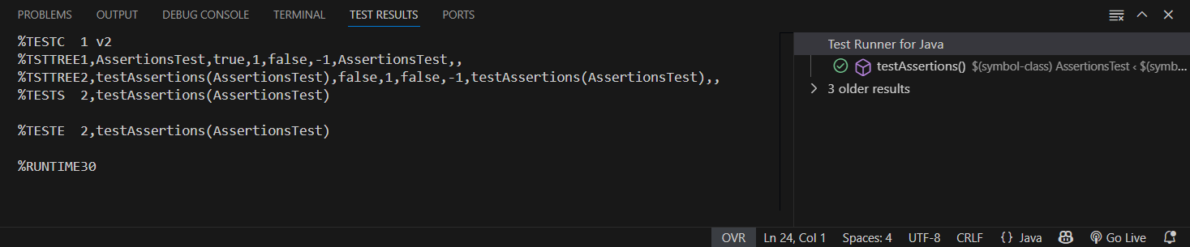

**Exercise 4:** Arrange-Act-Assert (AAA) Pattern, Test Fixtures, Setup and Teardown Methods in JUnit

**Scenario:** You need to organize your tests using the Arrange-Act-Assert (AAA) pattern and use setup and teardown methods.

**CODE:**

public class Calculator {

public int add(int a, int b) {

return a + b;

}

public int subtract(int a,int b) {

return a-b;

}

}

import org.junit.After;

import org.junit.Before;

import org.junit.Test;

import static org.junit.Assert.*;

public class CalculatorTest {

private Calculator calculator;

@Before

public void setUp() {

calculator = new Calculator();

System.out.println("Setup complete.");

}

@After

public void tearDown() {

calculator = null;

System.out.println("Teardown complete.");

}

@Test

public void testAdd() {

int a = 10;

int b = 5;

int result = calculator.add(a, b);

assertEquals("Addition failed", 15, result);

}

@Test

public void testSubtract() {

int a = 10;

int b = 5;

int result = calculator.subtract(a, b);

assertEquals("Subtraction failed", 5, result);

}

}

**OUTPUT:**

